Experimental Psychology
Name
Institution
Date

Experimental Psychology
Study One of the Article “Intensity of Smiling in Facebook Photos Predicts Future Life Satisfaction” by J. Patrick Seder and Shigehiro Oishi

Part 1: The Basics
1(A)
Variable name  (Stated at the  conceptual  level) | How was this  variable  operationalized in this  study? | Names of  the  variable’s  levels (if  relevant) | IV?  DV?  Or in the  case of a  co relational  study, just  “a variable” | Manipulated  or measured? | Independent  groups or  within  groups? Or n/  a?
Smile intensity | Comparison between the first smile and second smile intensity and how they compare with life satisfaction. | Nominal level | A variable | Manipulated | Independent groups
Life satisfaction 1 | What was the life satisfaction of the students at the end of the college 3.5 years later | Nominal level | Dependant variable | Measured | Within groups
Life satisfaction 2 | How does extraversion affect the life satisfaction and smile intensity | Nominal level | Dependant variable | Measured | Within groups
Extraversion | What level of extraversion inclusion would reduce association to zero | Nominal level | Dependant variable | Measured | Within the groups
Social relationships satisfaction | To what extend does smile intensity affect the quality of social relationship satisfaction at the end of the semester | Nominal level | A variable | Manipulated | Independent groups

1(B)
The study is a co relational study and for that matter a multivariate as it involves comparisons of the expected outcomes of the five variables. Through the use of life satisfaction and extraversion variables authors are able to predict their relation with level of smile intensity and social relationship satisfactions (Seder & Oishi, 2012). It is not a multiple regression since it has more than one dependant variable. The study does not have a mediator or a moderator.
1(C)
Text from the results  section (paste here,  and add quotation  marks and the page  number) | Insert a photo of your sketch  of the results in this box. | Why did you decide to  Sketch this result? Why is it  Important?
“In line with past research on sex differences in smiling, women (M =8.41, SD = 1.28) did smile more intensely than men (M = 7.04, SD =2.27), t(46) = 2.68, p = .01, d = .74.”(page 408) | 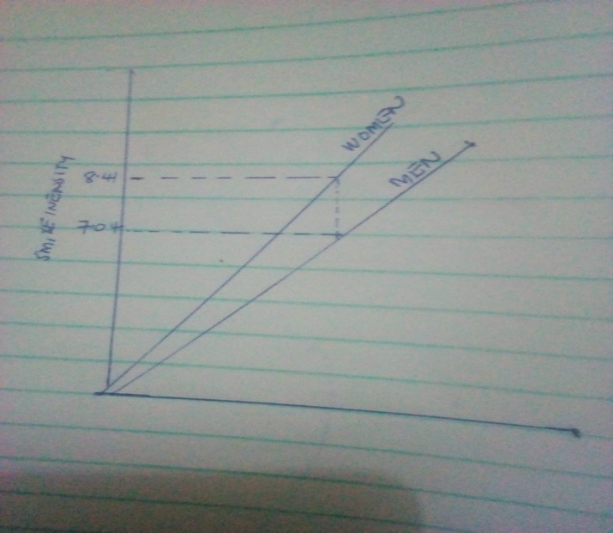 | The comparison between the intensity of smile between the men and women is very important aspect in the study.

Part 2: Applying the four big validities
2(A) Construct validity
Construct validity content  (paste here, and add  quotation marks and the  page number) | Interpretation and evaluation.  What does this content mean?  Does this represent good  Construct validity—if so, why? | What’s missing here? For  example, could they provide  more information to help  you decide if a measure or  manipulation is construct  valid?
“They also rated social relationships satisfaction in the following domains: friendships, family relationships, and social relationships in general (1 = extremely dissatisfied to 7 = extremely satisfied). Time 3 (end of final semester; Spring 2009)” (page 408). | The method uses inter-rater reliability which aims at relating the test outcomes of the study variables. The social relationship satisfactions as a result of the mentioned domains are acts as a supporting evidence of the study results.  Yes, It represents good constructive validity since it uses a common variable aspect that is, satisfaction | The validity lacks an observable variable like smiling in the case of the study. The study should have mentioned if there are other variables which relate with the social relationships satisfactions of the mentioned domains.

2(B)
The data collected and results are very precise since the findings represent the phenomenon of the main focus which is the life satisfaction as a result of smiling. The results gives valid and solid claims relating to the variables. The results of the study are very accurate and since the margin of errors are very minimal. There are several evidence of replicated statistics.
Statistical validity content  (paste here, and add  quotation marks and the page  number). You might also  include a figure or table from  the article here. | Interpretation and evaluation.  What does this content mean?  Be sure to address effect size,  and also address other  questions about statistical  validity. | What’s missing here? For  example, perhaps they  don’t include CIs? Perhaps  there’s no information on  replication?
“Controlling for first-semester life satisfaction, smile intensity in the Facebook profile photos still predicted life satisfaction measured 3.5 years later, b = .32, t(45) =2.60, p < .05, DR2 = .089, f 2 = .098.”( page 409) | These are the statistics for the expected results of life satisfactions for the fourth year as compared to first year.  The statistics demonstrated the indirect effect size between the life satisfactions over the 3.5 years since the results are found to be similar.  If the study had carried out more observations on the same there would be a likelihood of slight difference with in the results.  The statistics are reasonable as there is much expected difference in smiling from an individual. | The section does not indicate whether the first study and the second used the same sample size of the variables.

2(C) Internal validity
Internal validity content (paste here, adding  quotation marks and the page number). | Interpretation and evaluation. What does  this content mean for internal validity? Does  the study achieve this, or not?
“We compared those who completed the follow-up study with those who dropped out after Time 2; we found no differences in life satisfaction, extraversion, or social relationships satisfaction, |t|s < .77, ps > .44.1”(page 408) | The study involves a multi-group research which is represented by a threat of attrition, that the study considers the effects of the dropouts on the results of the study.  This content means that the results of the study can be trusted since they match with the sample used.  Yes, since the expected results as compared to other studies.

2(D) External validity
External validity content (paste here,  adding quotation marks and the page  number). | Interpretation and evaluation. What does  this content mean for external validity? Does  the study achieve this, or perhaps you don’t  know?
“Participants were required to be first-year students (in fall 2005) in the participant pool at University of Virginia and to have at least one Facebook profile photograph that could be retrieved and coded for smile intensity. A total of 92 participants (35 male) met these criteria and were invited to complete the follow-up measures given 3.5 years later (in their last semester at college). The final sample consisted of 48 participants (20 male)” (page 408) | The study appeared to use non probability sampling method since it is an external validity type which aims to generalize the findings of the sample. The use of this method makes the study more convenient.

Part 3: Assessing a causal claim
Causal claim (see instructions  above) | Analyze the claim here and draw a conclusion.
“Procedure for coding the expression of positive affect in photographs.” (page 408) | The study’s claim has been proven in other experimental studies. For instance a study conducted on the bases of positive psychology analyzed a group of participants who took a selfie for sometimes and it was observed that the positive affect of all the participants increased. This claim agrees with the causal criteria in the following ways; covariance as the authors assumes that the relationship of the variables and smile intensity will remain dependent in nature, temporal precedence in that the smiling acts as a controlling factor since it happens before the life satisfaction and finally internal validity since the study uses they use non probability sampling techniques.  I agree with the authors’ claim since have personally analyzed several photos in my face book account and my expressions depend on the occasions.

Part 4: Share it

The article “Intensity of Smiling in Facebook Photos Predicts Future Life Satisfaction” by J. Patrick Seder and Shigehiro Oishi
How often do you smile while taking a selfie? Did you know that your smile has an effect on someone’s psychology? This study article relates different variable in attempt to study the effects of your smile on life satisfaction.
 Retrieved from: https://technofaq.org/posts/2019/04/this-is-how-you-can-take-captivating-selfies-from-your-smartphone/
The study is a correlation study and therefore involves multiple variables because it involves comparing the expected results of five variables. By using extroverted and life satisfaction variables, the study can predict the relationship to smile intensity and social relationship satisfaction. The study is not a multiple regression because it has multiple dependent variables. The data and results collected are very accurate as the findings represent the main concern, which is the satisfaction with life that the smile brings.
The results give valid and reliable statements related to the variables. The results of this study are very accurate and the margin of error is small. There is some evidence of repeated statistics. These are statistics about expected life satisfaction results in year four compared to year one. Statistics show that since similar results were found, there has been an indirect impact between 3.5 years of life satisfaction. Research claims have been confirmed in other experimental studies. For example, a study based on positive psychology looked at a group of participants who occasionally took selfies and found that the positive influence of all participants was increasing.
Reference
Seder, J. P., & Oishi, S. (2012). Intensity of smiling in Facebook photos predicts future life satisfaction. Social Psychological and Personality Science, 3(4), 407-413.

